WireShark Lab-07

Maryam Masood 22i-1169

Question 03

HTTP:

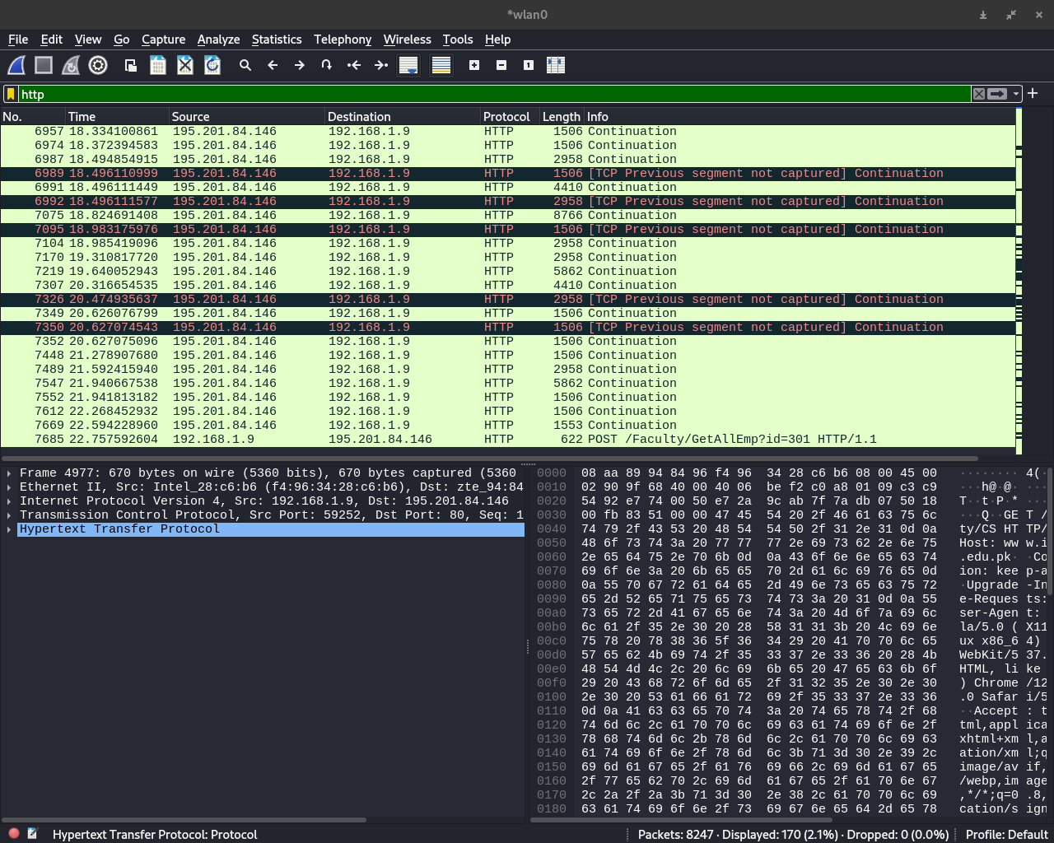

TCP:

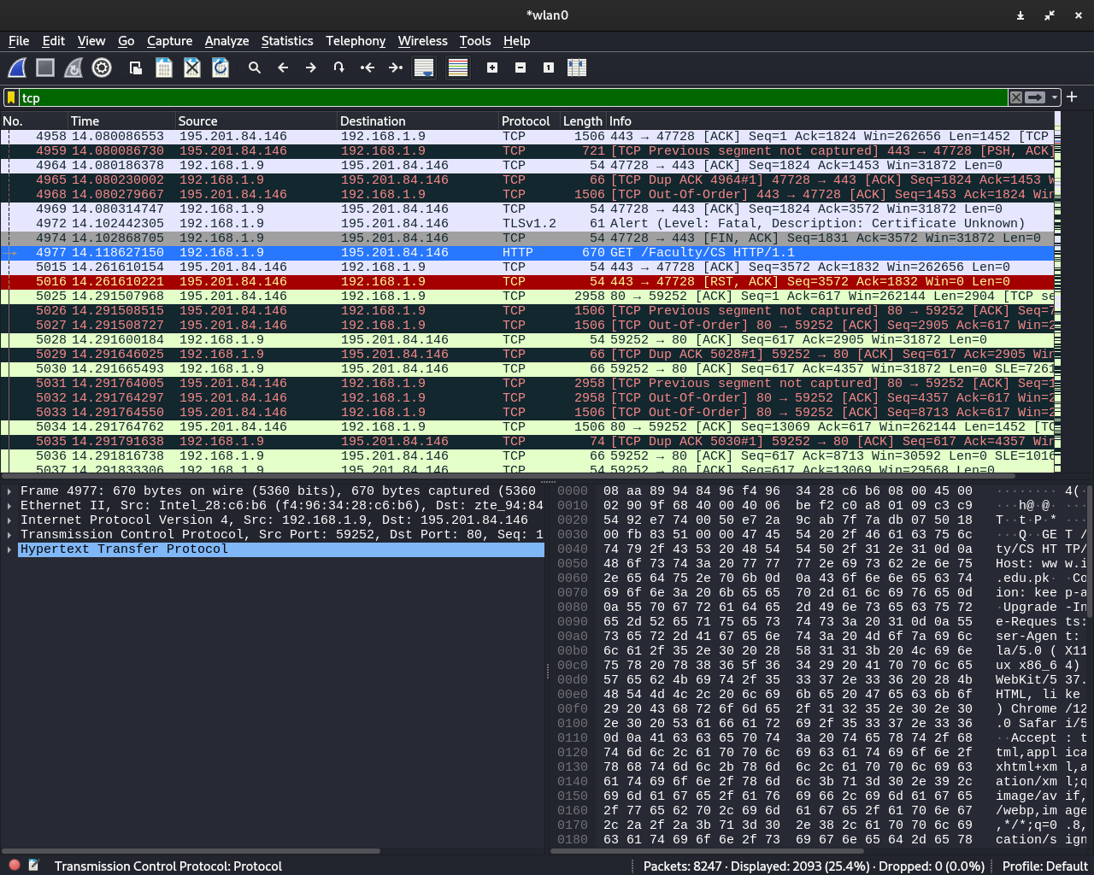

DNS:

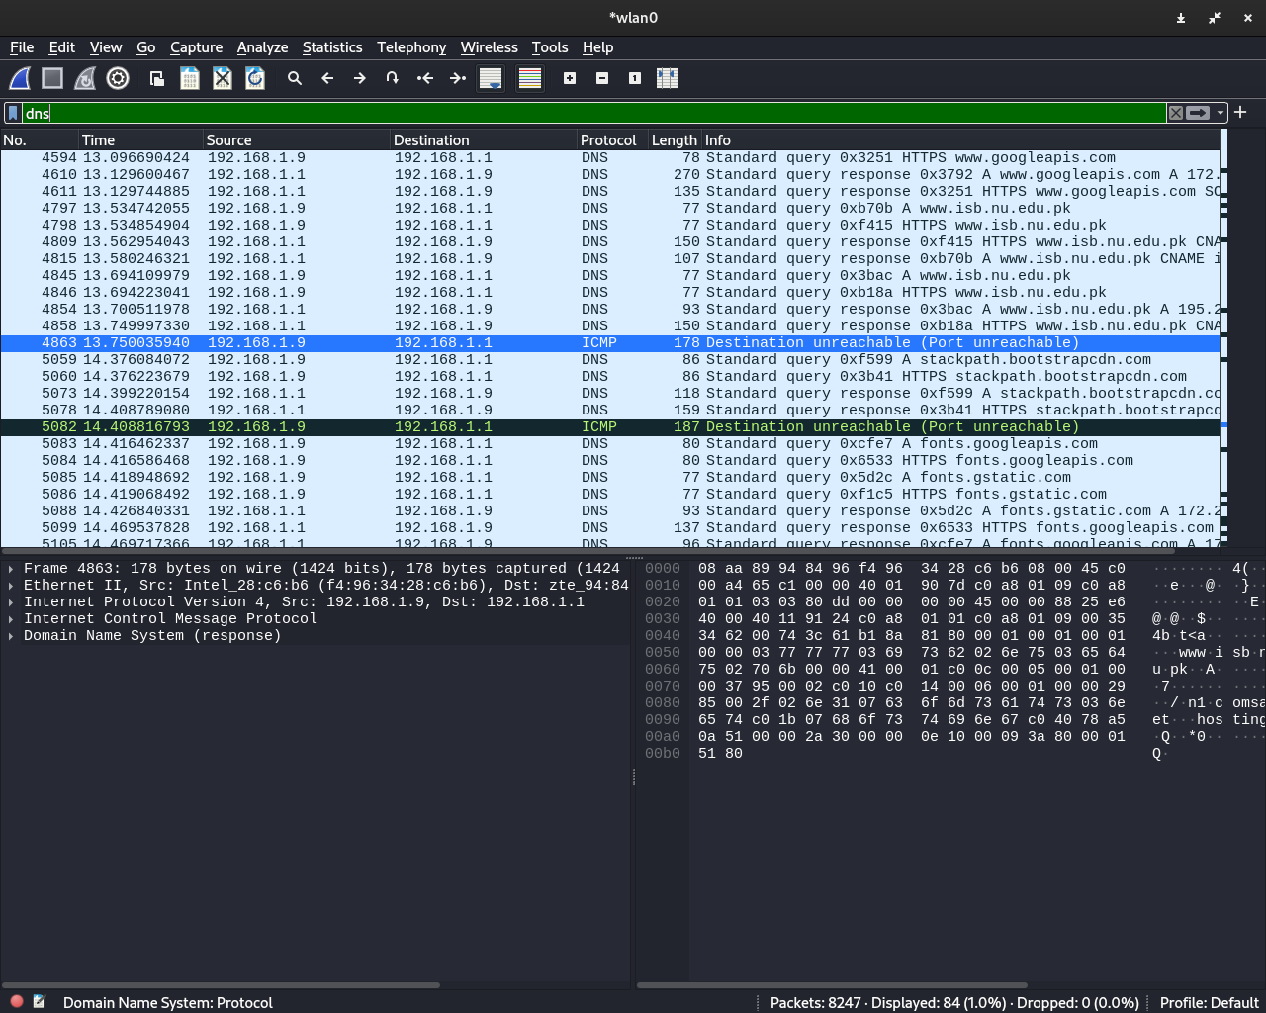

Question:04

IP address of machine: 192.168.1.9

IP address of destination server: 195.201.84.146



Question:05

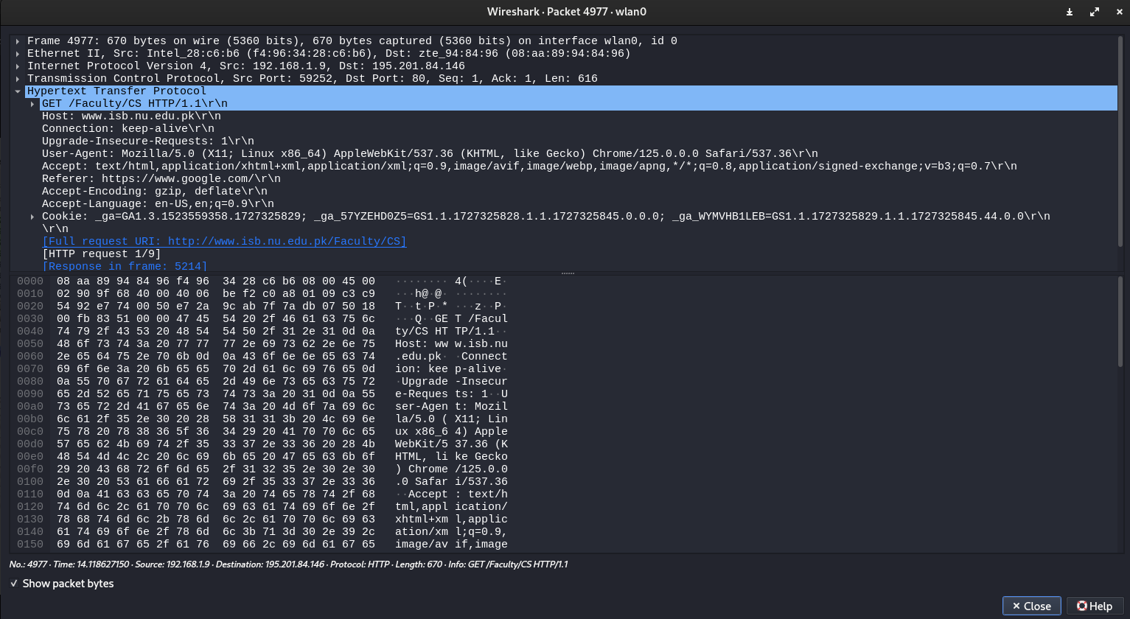

Source Port: 59252

Destination Port: 80

Question:06

